FOR IMMEDIATE RELEASE

PUBLIC RELATIONS SOCIETY OF AMERICA, LOS ANGELES CHAPTER RECOGNIZED CHAMPIONS OF DIVERSITY, EQUITY AND INCLUSION AT THE 2023 SUNRISE HONORS

LOS ANGELES – August 9, 2023 - The Public Relations Society of America Los Angeles Chapter (PRSA-LA), celebrated excellence in diversity, equity and inclusion with its fifth annual Sunrise Honors on August 4 at LA Plaza de Cultura y Artes in Downtown Los Angeles.

The PRSA-LA breakfast honored the following PR vanguards: Ellene V. Myles, Senior Vice President of Intersectional Marketing at Sony Pictures Entertainment/Motion Picture Group; Michelle O'Grady Caballero, M.A., Founder and CEO, Team Friday; Gabriel Reyes, President, Reyes Entertainment.

The Sunrise Honors celebration is part of PRSA-LA’s mission to foster and support those who promote diversity and inclusion. The honorees are trailblazers on the front lines in-and-out of the boardroom. This prestigious award recognizes individuals who have demonstrated significant leadership and influence to advance diversity and inclusivity within their organization or industry.

"We applaud the remarkable efforts of our honorees who have each ignited positive change and illuminated the path toward a more diverse and inclusive PR landscape. The fifth annual Sunrise Honors reaffirmed our commitment to fostering a society where every voice is heard, every perspective is valued, and every opportunity is accessible. These champions of diversity and inclusion inspire us all to break barriers and create a world that thrives on the strength of its differences," said Stephen Chavez, president of PRSA-LA and CEO of ChavezPR.

More on the 2023 Sunrise Honors honorees:

Ellene V. Myles is Senior Vice President of Intersectional Marketing at Sony Pictures Entertainment/Motion Picture Group focused on engaging the core audience, inclusive of LGBTQ+, AAPI, U.S. Hispanic, and Black moviegoers. Prior to joining Sony in 2018, Miles worked for nearly two decades as an agency partner with virtually every major studio in Hollywood, executing comprehensive campaigns for several television series, films, lifestyle brands and corporate entities. She is widely regarded in the industry as a strategic specialist, and her passion for increasing and maintaining visibility for multicultural press and brands has been a constant throughout her career. Miles held lead roles at Liquid Soul Media, Terry Hines & Associates' MRKT and her own boutique firm, EV Miles Media, and is the recipient of the Pat Tobin Award from the Black Public Relations Society, and the Media and Arts Award from Better Brothers Los Angeles. She began her career in 2000 with the famed boutique marketing and publicity firm The DuVernay Agency (DVA), owned by Ava DuVernay. Miles holds a Bachelor of Arts Degree in Public Relations and Advertising from California State University, Dominguez Hills and resides in the Los Angeles area.

Michelle O'Grady Caballero is a communications expert and strategist with experience in philanthropy, research, advocacy, campaigns, and partnerships. Using creative solutions to solve complex problems, Michelle advises foundations, nonprofit organizations, policymakers, and businesses on developing strategies to shift culture and connect communities.Her unique background in policy, media, tech, and business allows her to dot-connect issue areas, gather diverse people, and thread together solutions seamlessly. Michelle is the CEO and Founder of Team Friday, an impact advertising agency, and serves various boards and collaboratives, including the Washington Center for Technology Policy Inclusion, Support Latino Biz, #CASA, and Building Belonging. Michelle is a Google Next Gen Policy Leader, a graduate of Woodbury University, and has a Master’s in Media Psychology from Fielding Graduate University.

Gabriel Reyes is the founder of Reyes Entertainment, an award-winning communications agency based in Los Angeles. The agency offers multicultural and bilingual media relations, marketing and mobile solutions to a diverse roster of film, TV, celebrities and other entertainment clients and Lifestyle Brands across the U.S. and Mexico. Reyes also lectured at The University of Texas at Austin where he created the first Latino entertainment marketing course in the Department of Advertising. Reyes began his career as an actor and a model in New York City. He moved to Los and joined The Lee Solters Co. as vice president of the Latino Division. There, he helped launch Latina Magazine, securing Jennifer Lopez’s first magazine cover. In 1997, Reyes formed Reyes Entertainment, one of the first entertainment communications agencies in Hollywood dedicated to the underserved Latino market. Among his past and current clients are Hulu, HBO, PBS Primetime, Disney-ABC Television Group, Columbia Pictures, Fox Searchlight, Fiesta Broadway, Monster Energy Tour, WWE Wrestlemania, ALMA Awards, Imagen Awards, and Telemundo, among many others. Reyes was named one of The Hollywood Reporter’s 50 Most Powerful Latinos in Hollywood. Reyes has served on the Boards of OUTFEST, the L.A. Gay & Lesbian Film Festival and GLAAD (Gay & Lesbian Alliance Against Defamation). He is also a member of the Academy of TV Arts & Sciences and SAG-AFTRA.

Previous PRSA-LA Sunrise Honors honorees include Phylicia Fant, Founder and CEO of The Purple Agency; Amy Grindrod, Public Relations Director of Greater Los Angeles Agency on Deafness (GLAD); David C. Magdael, President and CEO of David Magdael & Associations, Inc.; Patricia Perez, CEO, VPE Communications; Valarie De La Garza, CEO of Fenton; Kim Hunter, Chairman and CEO of The LAGRANT Foundation, LAGRANT Communications and Managing Partner of KLH & Associates; Debra Nakatomi, President of NakatomiPR; Steve Roth, executive director for ORAHM – Organization for Refuge, Asylum & Migration; CBS Entertainment's Tiffany Smith Anoa'i; Bill Imada of IW Group; Gilbert Dávila of Dávila Multicultural Insights; Alan Acosta with the Los Angeles Gay and Lesbian Center; Rashad Robinson, Amity Paye and Rashid Shabazz of Color of Change; and Zandra Zuno Baermann with We Are UnidosUS.

About PRSA-LA
The Los Angeles Chapter of the Public Relations Society of America (PRSA-LA) comprises nearly 300 agency, in-house, and independent public relations professionals representing LA-area corporations, academic institutions, government agencies, and nonprofit organizations.

PRSA-LA was established in 1948 as one of PRSA's first five founding chapters. Members benefit from chapter events, educational and networking opportunities, industry advocacy, and professional development resources.

# # #
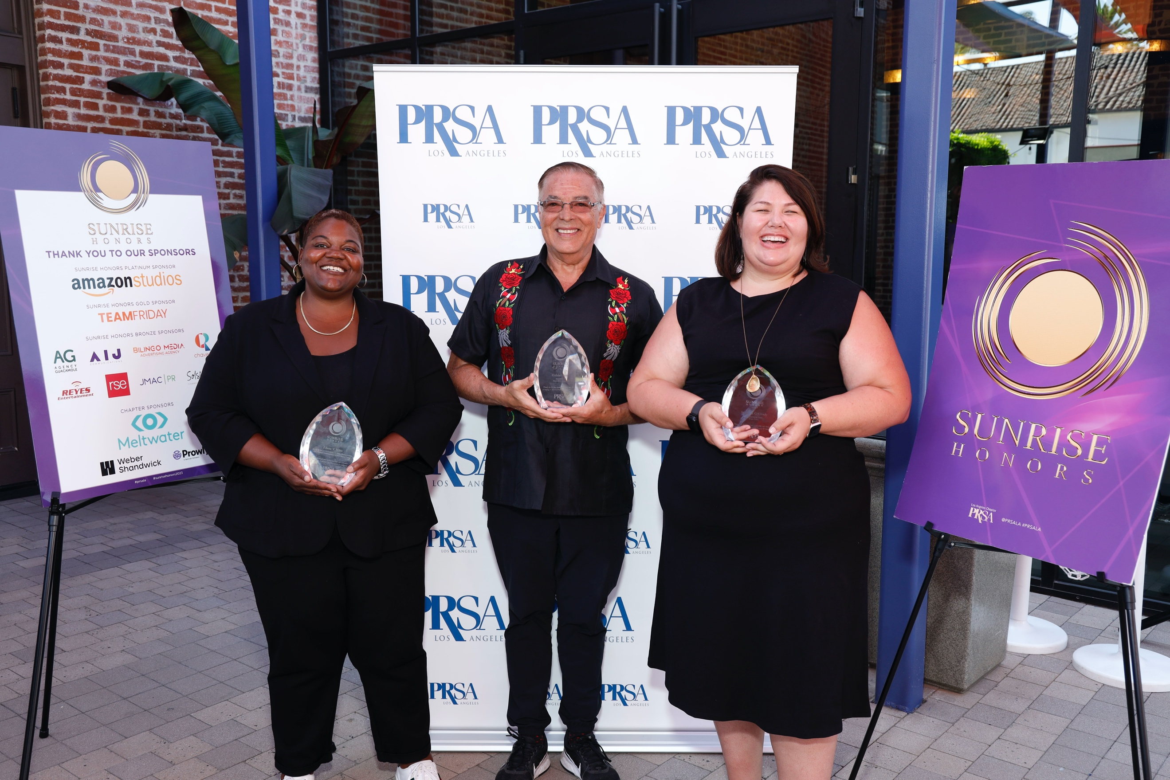
(From L-R) Ellene V. Myles, Senior Vice President of Intersectional Marketing at Sony Pictures Entertainment/Motion Picture Group; Gabriel Reyes, President, Reyes Entertainment, and Michelle O'Grady Caballero, M.A., Founder and CEO, Team Friday.

